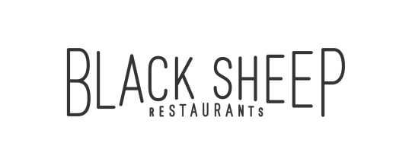

Black Sheep Restaurants is a Hong Kong-based hospitality group that specialises in developing niche, thought-provoking restaurant concepts that add to the existing culinary dialogue.

Whether recreating popular international concepts for the Hong Kong market or developing standalone restaurants, Black Sheep Restaurants curates distinct dining experiences that tell a story about a particular time, place, culture or cuisine while celebrating the bounty of premium ingredients available both locally and from abroad. The group currently boasts a portfolio of thirteen restaurants and bars, including Chôm Chôm, Motorino (Soho & Wan Chai), La Vache!, Ho Lee Fook, Carbone, Burger Circus, Stazione Novella, Le Garçon Saigon, BELON, Maison Libanaise, Buenos Aires Polo Club and Soul Food.

**ASSISTANT ASSOUNTANT**

**Main Responsibilities**

* Handle daily general accounting duties, data entry and filing
* Support accounting operations by filing documents and reconciling statements
* Maintain accounting systems by entering data as appropriate
* Provide support to finance team in day-to-day tasks when required
* Handle ad hoc assignments as required, special projects as assigned in all areas of finance department
* Providing support to the restaurants in relation to finance & accounting tasks
* Liaise with suppliers to resolve invoicing queries and support payment process

**Requirements**

* One year or above experience in Accounting / Finance preferred. New graduates considered.
* Good oral and written business communication skills in English.
* F.5 or above with LCC certificate or Diploma in accounting preferred
* Immediate availability is preferred
* Proficiency in MS Word, Excel for data manipulation
* Strong attention to detail, time organization skills and ability to work on own as well as part of a team.
* Experience in F&B industry and knowledge of restaurant operations is preferred, but not required

**BENEFITS**

* Competitive salary
* Quarterly discretional bonus
* 5 days work
* Staff discount
* Medical scheme
* Education sponsorship program
* Related training provided
* Discounted gymnastic membership program

Interested candidates can send their resume with **CURRENT and EXPECTED** salary to: [careers@blacksheeprestaurants.com.hk](mailto:careers@blacksheeprestaurants.com.hk) or call our HR Department at 2810 0062 with any questions.

*(All personal information collected would be kept strictly confidential and for recruitment purposes only.)*